**Research Methodology**

1. **Research Design**

The research design applied in the study is Descriptive research. Descriptive research is generally a fact-finding investigation with adequate interpretation and is designed to gather descriptive information for formulating more sophisticated studies. This is valuable in obtaining the facts needed for planning.

1. **Need for the study**

Previous studies have been made on topics like employee motivation, employee satisfaction, employee commitment, employee participation, etc. in TVS Logistics but not on Toolbox Meeting. Taking up this study would give an insight into the attitude and perception of the employees and also a new topic to research in the future. This is a pioneer attempt to know the effectiveness of tool box meeting. Hence the emergence of this study.

1. **Sources of Data**

**PRIMARY DATA**

The primary data was collected from TVS Logistics. Enough information was gathered with a structured questionnaire. The questionnaire consisted of 20 questions.

**SECONDARY DATA**

Previous research articles from ukessay, emerald sights, journals, and a few books were gone through.

1. **Sampling size and Sampling Techniques**

**SAMPLING TECHNIQUES**

The technique adopted in this study is Non-probability convenient sampling. Many researchers prefer this sampling technique because it is fast, cheap, easy and the subjects are readily available.

**SAMPLE SIZE**

A total of 100 employees responded to the questionnaire that was issued.

1. **Questionnaire Structure**

Respondents are offered a set of answers they have to choose from. Respondents are asked to answer the questionnaire which is sent through a link .The advantages of this questionnaires include their inexpensive price , time efficiency and respondents do not feel pressured.

1. **Statistical Tools used**

A questionnaire was used to collect the data from the employees

1. **Limitations**
   * + All the employees cannot be covered because of time constraint.
     + The absence of an in-person visit to the projects will not give a thorough understanding of the exact scenario.
     + The employees may not be fully transparent because of a telephonic survey.
     + Different projects are located in a different location and it is extremely difficult to visit all of them.
     + The data has been gathered using a questionnaire and hence it the limitations of the questionnaire are inherent in the report.
     + The research was done in a short span of time. So the possibility of widening the research is low.

**Questionnaire**

1. The Toolbox Meeting is being conducted under the shift supervisor.

[ ] Strongly Agree [ ] Agree [ ] Neutral [ ] Disagree [ ] Strongly Disagree

1. TBM takes place before every shift in your project.

[ ] Strongly Agree [ ] Agree [ ] Neutral [ ] Disagree [ ] Strongly Disagree

1. The Toolbox Meetings usually lasts for about 15-20 minutes.

[ ] Strongly Agree [ ] Agree [ ] Neutral [ ] Disagree [ ] Strongly Disagree

1. The meetings usually have a strength of 20-25 employees.

[ ] Strongly Agree [ ] Agree [ ] Neutral [ ] Disagree [ ] Strongly Disagree

1. The employees are often allowed to give suggestions in the meetings.

[ ] Strongly Agree [ ] Agree [ ] Neutral [ ] Disagree [ ] Strongly Disagree

1. Rewards and Recognition are often given in meetings.

[ ] Strongly Agree [ ] Agree [ ] Neutral [ ] Disagree [ ] Strongly Disagree

1. Customer representatives are often invited to the meetings and their inputs are considered.

[ ] Strongly Agree [ ] Agree [ ] Neutral [ ] Disagree [ ] Strongly Disagree

1. The Key Account Manager (KAM) attends the meeting regularly.

[ ] Strongly Agree [ ] Agree [ ] Neutral [ ] Disagree [ ] Strongly Disagree

1. Safety aspect talks are given prime focus in the Toolbox Meetings.

[ ] Strongly Agree [ ] Agree [ ] Neutral [ ] Disagree [ ] Strongly Disagree

1. Kaizen (Continuous improvement) is discussed frequently in the meetings.

[ ] Strongly Agree [ ] Agree [ ] Neutral [ ] Disagree [ ] Strongly Disagree

1. Employees’ concerns are addressed by the shift supervisors.

[ ] Strongly Agree [ ] Agree [ ] Neutral [ ] Disagree [ ] Strongly Disagree

1. TBM contributes significantly to the Customer Satisfaction Index (CSI) score.

[ ] Strongly Agree [ ] Agree [ ] Neutral [ ] Disagree [ ] Strongly Disagree

1. TBM drastically contributes to reducing safety incidents.

[ ] Strongly Agree [ ] Agree [ ] Neutral [ ] Disagree [ ] Strongly Disagree

1. An adequate number of suggestions is being generated in a month.

[ ] Strongly Agree [ ] Agree [ ] Neutral [ ] Disagree [ ] Strongly Disagree

1. The achievements of employees are often celebrated in the meetings.

[ ] Strongly Agree [ ] Agree [ ] Neutral [ ] Disagree [ ] Strongly Disagree

1. Discussions on personal concerns like salary and welfare issues are often discussed in the meetings

[ ] Strongly Agree [ ] Agree [ ] Neutral [ ] Disagree [ ] Strongly Disagree

1. The Operations manager often participates in the TBM.

[ ] Strongly Agree [ ] Agree [ ] Neutral [ ] Disagree [ ] Strongly Disagree

1. The project HR regularly participates in the TBM.

[ ] Strongly Agree [ ] Agree [ ] Neutral [ ] Disagree [ ] Strongly Disagree

1. TBM helps in increasing the productivity of the project.

[ ] Strongly Agree [ ] Agree [ ] Neutral [ ] Disagree [ ] Strongly Disagree

1. TBM contributes to the smooth running of day-to-day work.

[ ] Strongly Agree [ ] Agree [ ] Neutral [ ] Disagree [ ] Strongly Disagree

**DATA ANALYSIS**

A questionnaire was prepared for the purpose of this study and Likert 5-point scale was used for the research analysis. A sample of 100 employees was chosen at random. Convenient sampling was used and the data collected is interpreted in the following pie charts.

**Table 4.1 Classification of employees based on age**

|  |  |  |
| --- | --- | --- |
|  | **Frequency** | **Percentage** |
| Below 30 | 37 | 37 |
| 31-40 | 49 | 49 |
| 41-50 | 12 | 12 |
| 50 and above | 2 | 2 |
| **Total** | 100 | 100 |

From the pie chart, we can understand that 49% of the employees are between the age group 31-40. 37% of them are below 30 years. 12% of the employees are between the age group 41-50 and the remaining 2% are 50 years and above. Overall, we can say that the majority of them are between 31- 40 years.

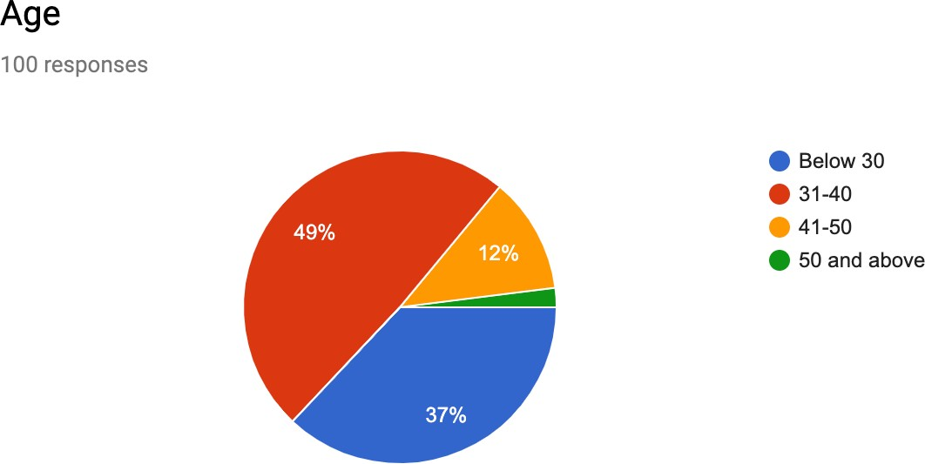

**Figure 4.1 Classification of employees based on age**

**Table 4.2 Classification of employees based on experience**

|  |  |  |
| --- | --- | --- |
|  | **Frequency** | **Percentage** |
| 0-5 years | 61 | 61 |
| 5-10 years | 33 | 33 |
| 10-15 years | 4 | 4 |
| 15 and above | 2 | 2 |
| **Total** | 100 | 100 |

From the chart, we can infer that 61% of the employees have 0-5 years of experience. 33% have 5-10 years of experience and 4 employees have 10-15 years of experience. Only 2 of them have 15 or more years of experience. Overall, the majority of the employees have 0-5 years of experience.

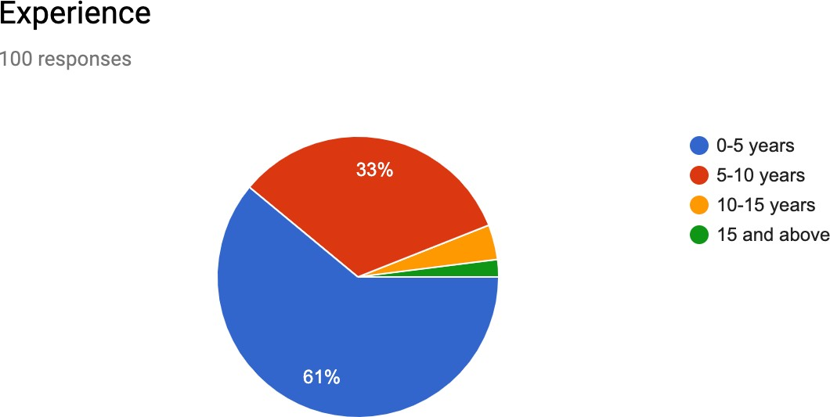

**Figure 4.2 Classification of employees based on experience**

**Table 4.3 Conduct of TBM under the shift supervisor**

|  |  |  |
| --- | --- | --- |
|  | **Frequency** | **Percentage** |
| Strongly Agree | 79 | 79 |
| Agree | 12 | 12 |
| Neutral | 5 | 5 |
| Disagree | 4 | 4 |
| Strongly Disagree | - | - |
| **Total** | 100 | 100 |

From the pie chart, we can infer that 79% of the employees have strongly agreed that the shift supervisor regularly conducts the Toolbox Meeting. 12% have agreed that the meetings take place under the supervision of the shift supervisor. 5% have remained neutral in their response and the remaining 4% have disagreed that the meetings take place under the supervision of the shift supervisor. Overall, we can tell that the majority of the employees have answered that the Toolbox meetings are conducted under the shift supervisor.

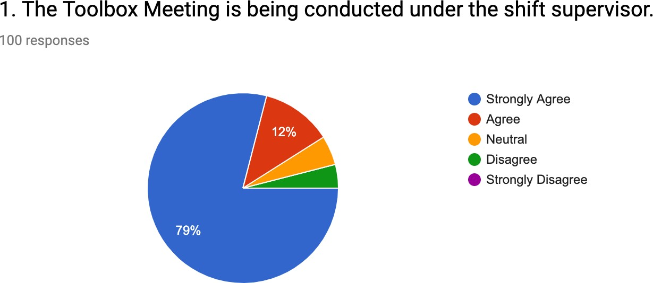

**Figure 4.3 Conduct of TBM under the shift supervisor**

**Table 4.4 Frequency of TBM before every shift**

|  |  |  |
| --- | --- | --- |
|  | **Frequency** | **Percentage** |
| Strongly Agree | 10 | 10 |
| Agree | 82 | 82 |
| Neutral | 3 | 3 |
| Disagree | 5 | 5 |
| Strongly Disagree | - | - |
| **Total** | 100 | 100 |

From the chart, we can tell that 82 employees have responded that the Toolbox Meeting takes place before every shift. 10 of them have strongly agreed that the meetings take place before every shift. 3 employees have stayed neutral in their answers. 5 employees have disagreed that the meetings take place before every shift in the projects. Overall, it can be understood that most of the employees have told that the meetings take place before every shift.

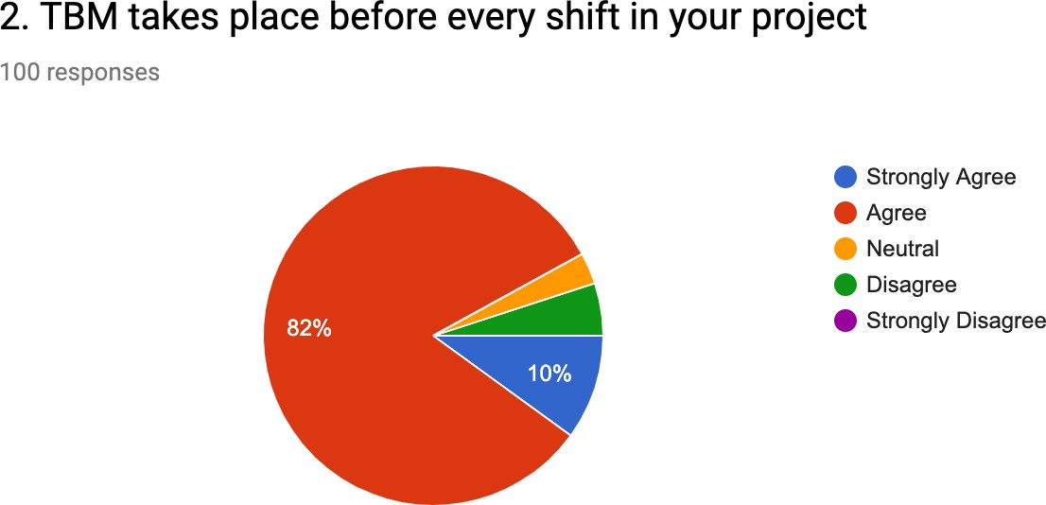

**Figure 4.4 Frequency of TBM before every shift**

**Table 4.5 Duration of the TBM**

|  |  |  |
| --- | --- | --- |
|  | **Frequency** | **Percentage** |
| Strongly Agree | 4 | 4 |
| Agree | 16 | 16 |
| Neutral | 73 | 73 |
| Disagree | 7 | 7 |
| Strongly Agree | - | - |
| **Total** | 100 | 100 |

From the diagram, we can understand that 4% of the employees have strongly agreed that Toolbox Meeting lasts for about 15-20 minutes. 16% of them have agreed with the statement. 73% have stayed neutral in their answers. 7% have disagreed the meetings take about 15-20 minutes. Overall, we can say that majority of the respondents have stayed neutral in their answers.

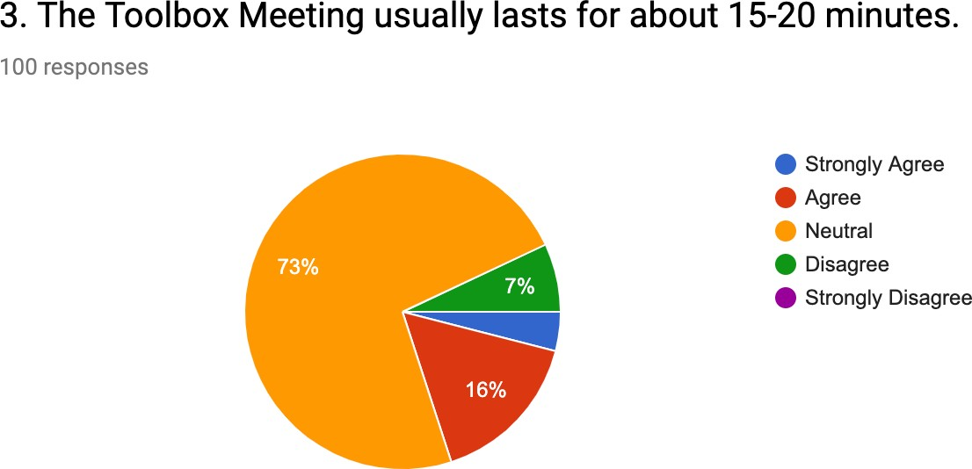

**Figure 4.5 Duration of the TBM**

**Table 4.6 Strength present in TBM**

|  |  |  |
| --- | --- | --- |
|  | **Frequency** | **Percentage** |
| Strongly Agree | 4 | 4 |
| Agree | 9 | 9 |
| Neutral | 35 | 35 |
| Disagree | 52 | 52 |
| Strongly Disagree | - | - |
| **Total** | 100 | 100 |

From the chart, we can infer that 52% of the employees have disagreed that the Toolbox Meetings have the strength of 20-25 employees. 35% of the employees have neither agreed nor disagreed. 9% have agreed that the meetings have a strength of 20-25 employees. The remaining 4% of them have strongly agreed that the meetings consist of 20-25 employees. Overall, we can say that the majority of them have disagreed that the meetings have a strength of 20-25 employees.

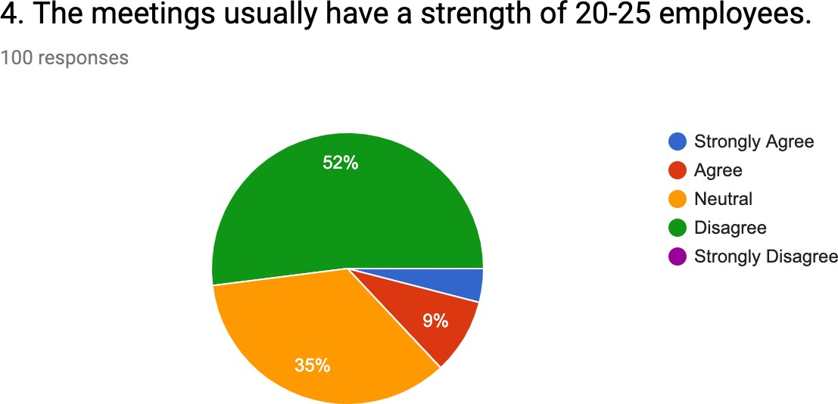

**Figure 4.6 Strength present in TBM**

**Table 4.7 Permission to give suggestions in TBM**

|  |  |  |
| --- | --- | --- |
|  | **Frequency** | **Percentage** |
| Strongly Agree | 4 | 4 |
| Agree | 77 | 77 |
| Neutral | 7 | 7 |
| Disagree | 10 | 10 |
| Strongly Disagree | 2 | 2 |
| **Total** | 100 | 100 |

From the chart, we can understand that 4 employees have strongly agreed that they are allowed to give suggestions in the meetings. 77 of them have agreed that they are allowed to give their suggestions. 7 employees have stayed neutral in their answers. 10 have disagreed that they are allowed to give suggestions in the Toolbox Meeting. The remaining 2 have strongly disagreed with the statement. Overall, it can be inferred that the majority of them have agreed that they are allowed to give suggestions in the meetings.

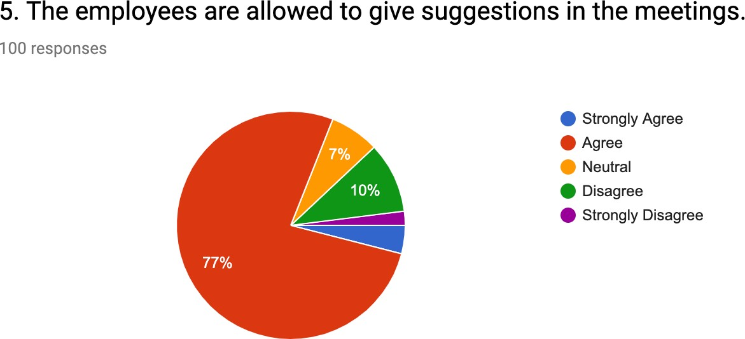

**Figure 4.7 Permission to give suggestions in TBM**

**Table 4.8 Recognition of employees in TBM**

|  |  |  |
| --- | --- | --- |
|  | **Frequency** | **Percentage** |
| Strongly Agree | 7 | 7 |
| Agree | 53 | 53 |
| Neutral | 34 | 34 |
| Disagree | 6 | 6 |
| Strongly Disagree | - | - |
| **Total** | 100 | 100 |

From the pie chart, we can understand that 53% of the respondents have agreed that reward and recognition are often given in the meetings. 7% have strongly agreed with the statement. 34% have stayed neutral in their answers. The remaining 6% have disagreed that rewards and recognition are often given in the Toolbox Meeting. Overall, it can be said that the majority of them have agreed that rewards and recognition are given in the meetings.

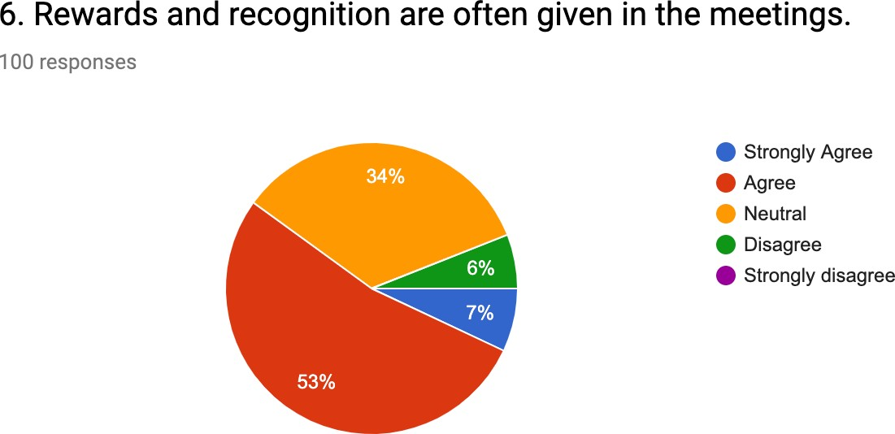

**Figure 4.8 Recognition of employees in TBM**

**Table 4.9 Invitation to customers for attending TBM**

|  |  |  |
| --- | --- | --- |
|  | **Frequency** | **Percentage** |
| Strongly Agree | 4 | 4 |
| Agree | 9 | 9 |
| Neutral | 29 | 29 |
| Disagree | 56 | 56 |
| Strongly Disagree | 2 | 2 |
| **Total** | 100 | 100 |

From the diagram, we can say that 56% of the employees have disagreed stating that customer representatives are often invited to the meetings and their inputs are considered. 2% have strongly disagreed with the statement. 29% have been neutral in their answers and 9% of the employees have agreed with the above statement. The remaining 4% have strongly agreed that customers are invited and their inputs are being considered. Overall, the majority of the employees have disagreed with the above statement.

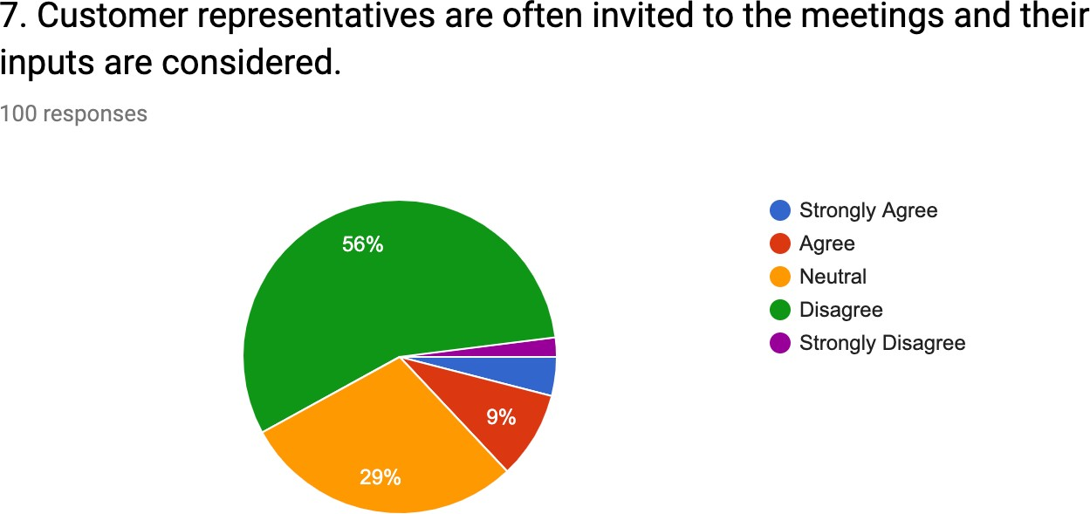

**Figure 4.9 Invitation to customers for attending TBM**

**Table 4.10 Participation of KAM in TBM**

|  |  |  |
| --- | --- | --- |
|  | **Frequency** | **Percentage** |
| Strongly Agree | 1 | 1 |
| Agree | 8 | 8 |
| Neutral | 46 | 46 |
| Disagree | 41 | 41 |
| Strongly Disagree | 4 | 4 |
| **Total** | 100 | 100 |

From the pie chart, we can infer that 46 employees have neither agreed nor disagreed with the above statement. 41 employees have disagreed and 4 employees have strongly disagreed that the Key Account Manager attends the meetings regularly. 8 of them have agreed that the KAM attends the meetings regularly. Only 1 employee has strongly agreed that the Key Account Manager attends the meetings regularly. Overall, it can be said that the majority of the employees have stayed neutral with their response.

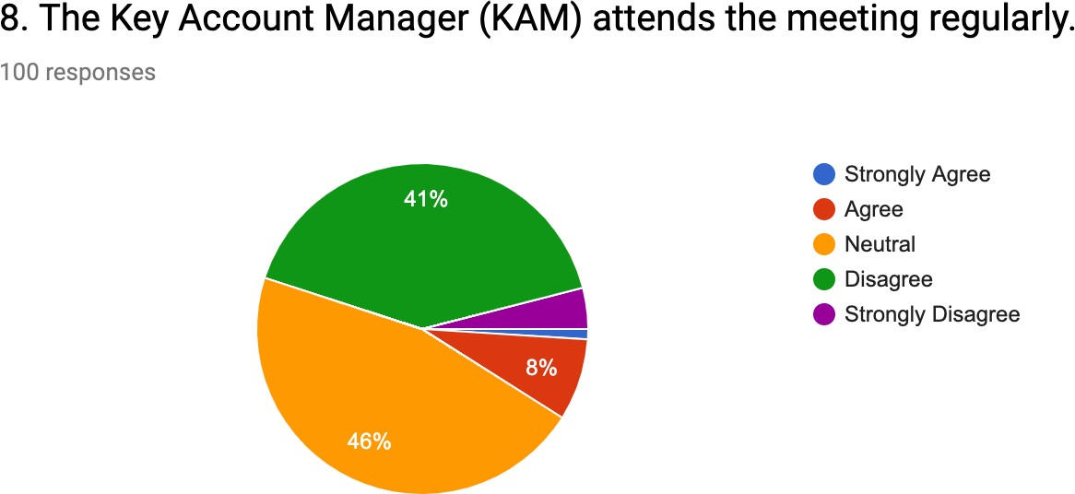

**Figure 4.10 Participation of KAM in TBM**

**Table 4.11 Safety aspect talks in TBM**

|  |  |  |
| --- | --- | --- |
|  | **Frequency** | **Percentage** |
| Strongly Agree | 79 | 79 |
| Agree | 13 | 13 |
| Neutral | 3 | 3 |
| Disagree | 4 | 4 |
| Strongly Disagree | 1 | 1 |
| **Total** | 100 | 100 |

From the chart, we can infer that 79% of the employees have strongly agreed that safety aspect talks are given prime focus in the Toolbox Meetings. 13% have agreed with the above statement. 3% of the employees have stayed neutral in their answer and 4% have disagreed with the statement. The remaining 1% of the employees have strongly disagreed that safety talks are given prime focus in the meetings. Overall, it can be said that the majority of them have strongly agreed that safety aspect talks given prime focus in the Toolbox Meetings.

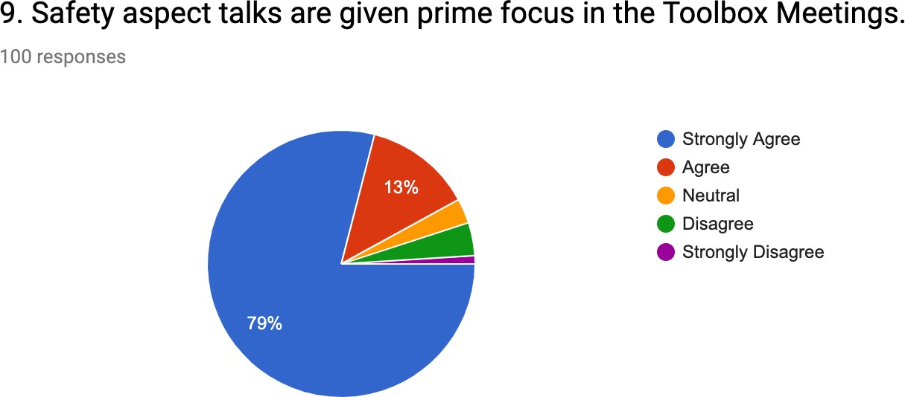

**Figure 4.11 Safety aspect talks in TBM**

**Table 4.12 Discussion about Kaizen in the meetings**

|  |  |  |
| --- | --- | --- |
|  | **Frequency** | **Percentage** |
| Strongly Agree | 7 | 7 |
| Agree | 22 | 22 |
| Neutral | 63 | 63 |
| Disagree | 8 | 8 |
| Strongly Disagree | - | - |
| **Total** | 100 | 100 |

From the diagram, we can be sure that 63% of the employees have stayed neutral when asked if Kaizen has been discussed in the meetings. 8% of them have disagreed with the above statement. 22% of the employees have agreed that Kaizen has been discussed in the meetings. The other 7% have strongly agreed with the statement. Overall, it can found that the majority of the respondents have neither agreed nor disagreed with the statement.

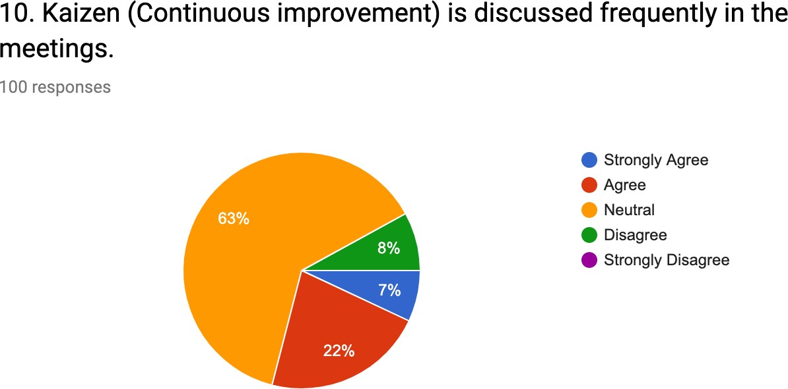

**Figure 4.12 Discussion about Kaizen in the meetings**

**Table 4.13 Consideration of employees’ concerns by shift supervisor**

|  |  |  |
| --- | --- | --- |
|  | **Frequency** | **Percentage** |
| Strongly Agree | 8 | 8 |
| Agree | 78 | 78 |
| Neutral | 5 | 5 |
| Disagree | 8 | 8 |
| Strongly Disagree | 1 | 1 |
| **Total** | 100 | 100 |

From the pie chart, we can tell that 78 employees have agreed that the shift supervisors address their concerns. 8 of them have strongly agreed that their concerns are being taken care of by the shift supervisors. 5 have stayed neutral in their answers and 8 have disagreed that the shift supervisors address their concerns. Only 1 employee has strongly disagreed with the statement. Overall, we can say that the majority of the employees have agreed that the shift supervisors address their concerns.

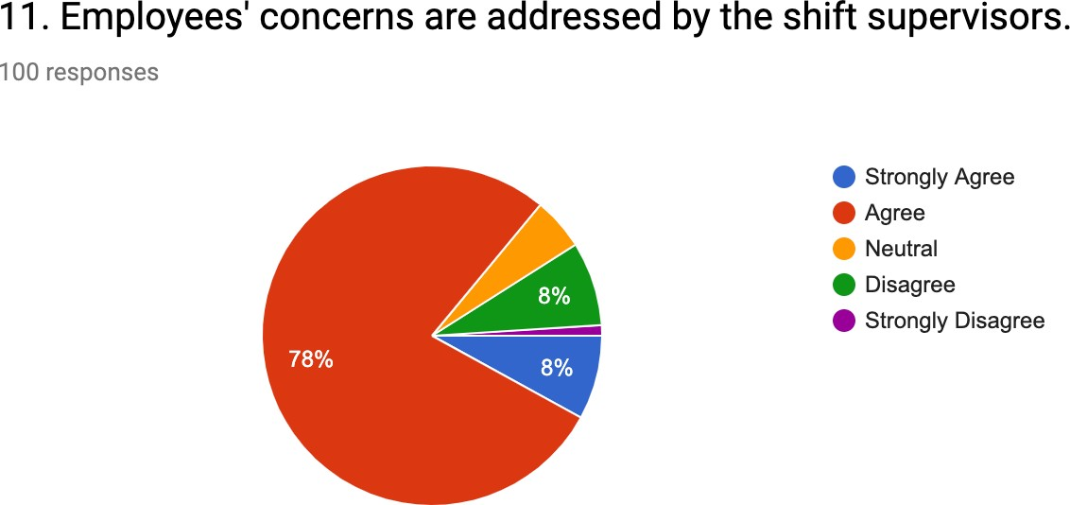

**Figure 4.13 Consideration of employees’ concerns by shift supervisor**

**Table 4.14 Contribution of TBM to CSI score**

|  |  |  |
| --- | --- | --- |
|  | **Frequency** | **Percentage** |
| Strongly Agree | 4 | 4 |
| Agree | 14 | 14 |
| Neutral | 68 | 68 |
| Disagree | 14 | 14 |
| Strongly Disagree | - | - |
| **Total** | 100 | 100 |

From the diagram, we can say that can tell that 4% of the employees have strongly agreed that the Toolbox Meeting contributes significantly to the CSI score. 14% have agreed that TBM contributes to the CSI score. 68% have stayed neutral in their answer. The remaining 14% have disagreed that TBM contributes significantly to the Customer Satisfaction Index score. Overall, it can be said that most of the respondents have stayed neutral with the above statement.

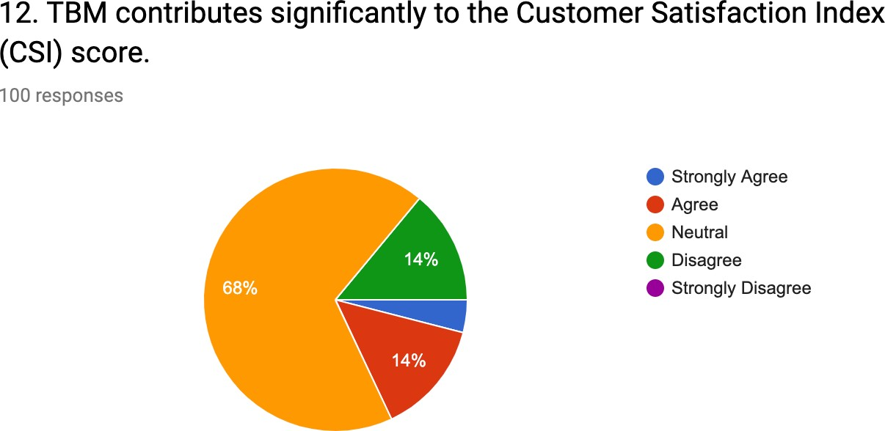

**Figure 4.14 Contribution of TBM to CSI score**

**Table 4.15 Contribution of TBM in reducing safety incidents**

|  |  |  |
| --- | --- | --- |
|  | **Frequency** | **Percentage** |
| Strongly Agree | 76 | 76 |
| Agree | 15 | 15 |
| Neutral | 6 | 6 |
| Disagree | 2 | 2 |
| Strongly Disagree | 1 | 1 |
| **Total** | 100 | 100 |

From the diagram, we can infer that 76% of the employees have strongly agreed that the Toolbox Meeting drastically contributes to reducing the safety incidents. 15% of them have agreed with the above statement. 6% of the respondents have neither agreed nor disagreed with the statement. 2% of the employees have disagreed that TBM drastically contributes to reducing safety incidents. The remaining 1% has strongly disagreed with the statement. Overall, it can be inferred that the majority of the responses are positive to the statement.

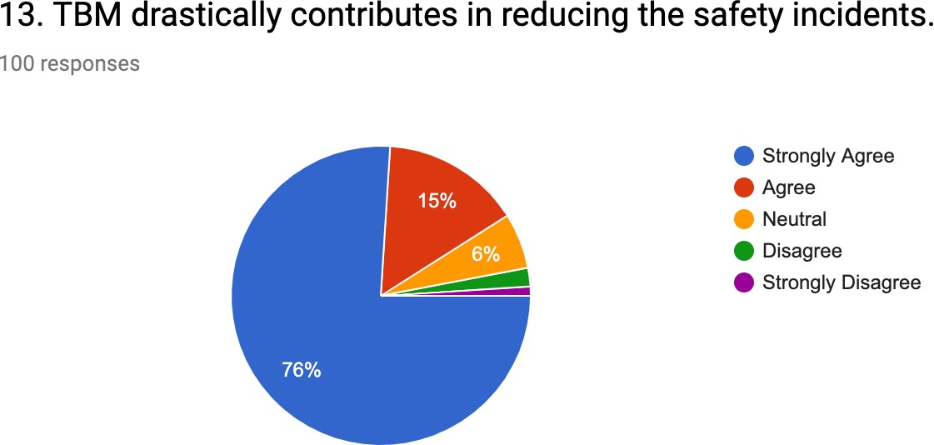

**Figure 4.15 Contribution of TBM in reducing safety incidents**

**Table 4.16 Generation of suggestions in a month**

|  |  |  |
| --- | --- | --- |
|  | **Frequency** | **Percentage** |
| Strongly Agree | 1 | 1 |
| Agree | 48 | 48 |
| Neutral | 25 | 25 |
| Disagree | 23 | 23 |
| Strongly Disagree | 3 | 3 |
| **Total** | 100 | 100 |

From the table, we can tell that 48 employees have agreed that an adequate number of suggestions is being generated in one month. 25 employees have stayed neutral in their answers and 23 have disagreed that enough number of suggestions is being generated in a month. 3 of them have strongly disagreed with the statement and 1 has strongly agreed that suggestions are being generated in a month. Overall, the majority of the employees have agreed that an adequate number of suggestions are being generated in a month.

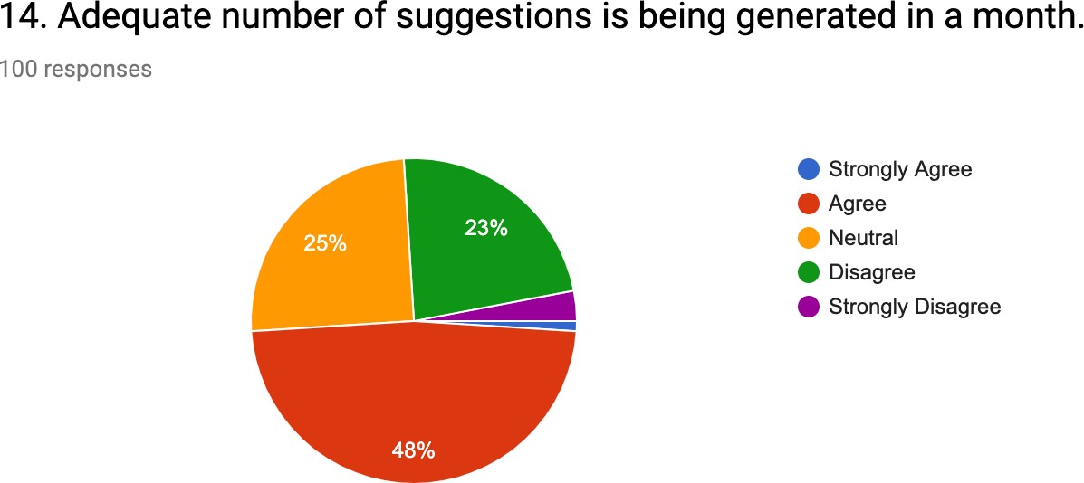

**Figure 4.16 Generation of suggestions in a month**

**Table 4.17 Celebration of employees’ achievements in TBM**

|  |  |  |
| --- | --- | --- |
|  | **Frequency** | **Percentage** |
| Strongly Agree | 5 | 5 |
| Agree | 75 | 75 |
| Neutral | 12 | 12 |
| Disagree | 7 | 7 |
| Strongly Disagree | 1 | 1 |
| **Total** | 100 | 100 |

From the pie chart, we can infer that 75% of the respondents have agreed that their achievements are celebrated in the Toolbox Meeting. 5% of the respondents have strongly agreed to the above statement. 12% have stayed neutral in their response. 7% of the respondents have disagreed with the statement and the remaining 1% has strongly disagreed with the statement. Overall, the majority of them have told that the achievements of the employees are regularly celebrated in the meetings.

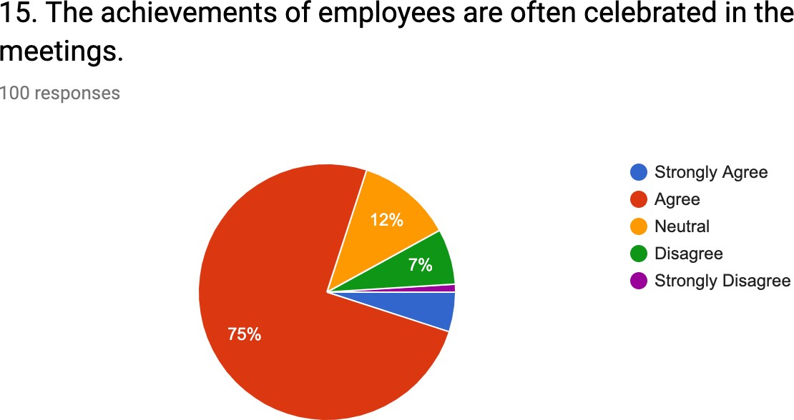

**Figure 4.17 Celebration of employees’ achievements in TBM**

**Table 4.18 Discussion on personal concerns in TBM**

|  |  |  |
| --- | --- | --- |
|  | **Frequency** | **Percentage** |
| Strongly Agree | 2 | 2 |
| Agree | 6 | 6 |
| Neutral | 36 | 36 |
| Disagree | 54 | 54 |
| Strongly Disagree | 2 | 2 |
| **Total** | 100 | 100 |

From the chart, we can infer that 54% of the employees have disagreed with the fact that personal concerns like salary and welfare issues are discussed in the meetings. 36% have neither agreed nor disagreed with the statement. 2% has strongly agreed that concerns like salary and welfare issues are discussed in the meetings and another 6% has also agreed with the same. The rest 2% has strongly disagreed with the statement. Overall, it can be said that personal concerns like salary and welfare issues are not much discussed in the meetings.

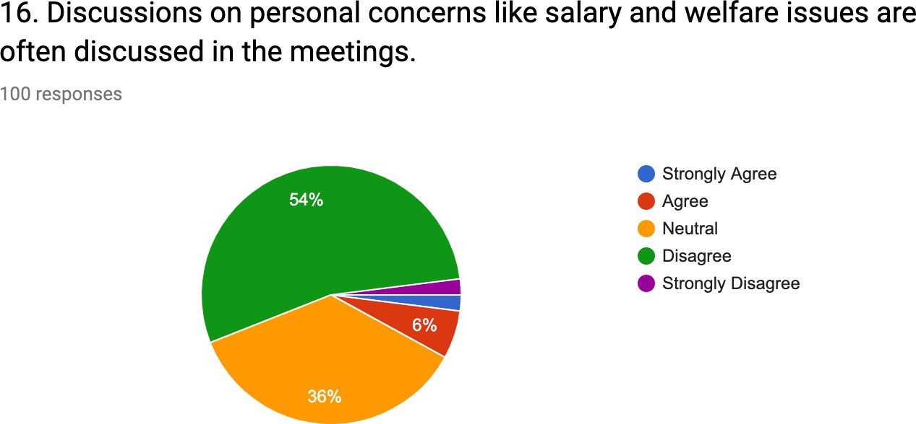

**Figure 4.18 Discussion on personal concerns in TBM**

**Table 4.19 Participation of operations manager in TBM**

|  |  |  |
| --- | --- | --- |
|  | **Frequency** | **Percentage** |
| Strongly Agree | 1 | 1 |
| Agree | 13 | 13 |
| Neutral | 67 | 67 |
| Disagree | 19 | 19 |
| Strongly Disagree | - | - |
| **Total** | 100 | 100 |

From the chart, we can tell that 67% of the employees have been neutral in their answer when asked if the operations manager attends the meetings regularly. 19% have disagreed that the operations manager attends the meetings regularly. 13% of the employees have agreed that the operations manager attends the meetings regularly and the remaining 1% has strongly agreed with the statement. Overall, it can be said that the majority of the employees have stayed neutral in their answers for the above-mentioned statement.

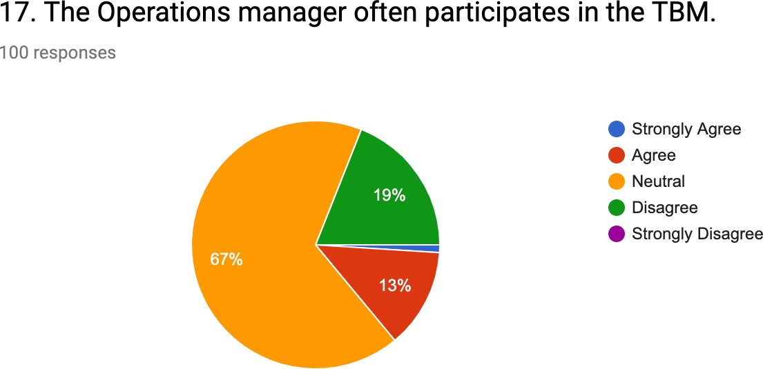

**Figure 4.19 Participation of operations manager in TBM**

**Table 4.20 Participation of project HR in TBM**

|  |  |  |
| --- | --- | --- |
|  | **Frequency** | **Percentage** |
| Strongly Agree | 5 | 5 |
| Agree | 72 | 72 |
| Neutral | 13 | 13 |
| Disagree | 10 | 10 |
| Strongly Disagree | - | - |
| **Total** | 100 | 100 |

From the diagram we can be sure that 72 respondents have agreed that the project HR regularly participates in the Toolbox Meetings. 5 of them have strongly agreed with the above statement. 13 employees have stayed neutral in their answers and the remaining 10 respondents have disagreed when asked if the project HR regularly participates in the TBM. Overall, it can be said that the project HR almost participates in every Toolbox Meeting.

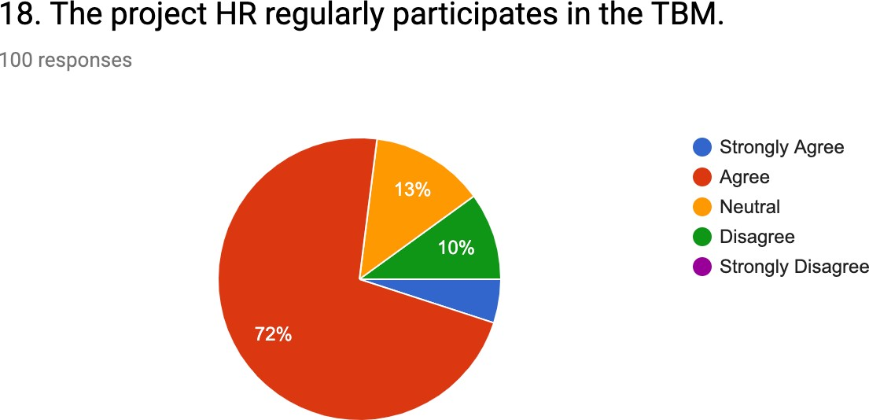

**Figure 4.20 Participation of project HR in TBM**

**Table 4.21 Contribution of TBM in increasing productivity of project**

|  |  |  |
| --- | --- | --- |
|  | **Frequency** | **Percentage** |
| Strongly Agree | 67 | 67 |
| Agree | 28 | 28 |
| Neutral | 3 | 3 |
| Disagree | 2 | 2 |
| Strongly Disagree | - | - |
| **Total** | 100 | 100 |

From the diagram, we can infer that 67% of the employees have strongly agreed that Toolbox Meetings increase the productivity of the project. 28% of the employees have agreed with the statement. 3% have neither agreed nor disagreed with the statement. The remaining 2% has disagreed when asked if the TBM helps in increasing the productivity of the project. Overall, it can be said that TBM does help in increasing the productivity of the project.

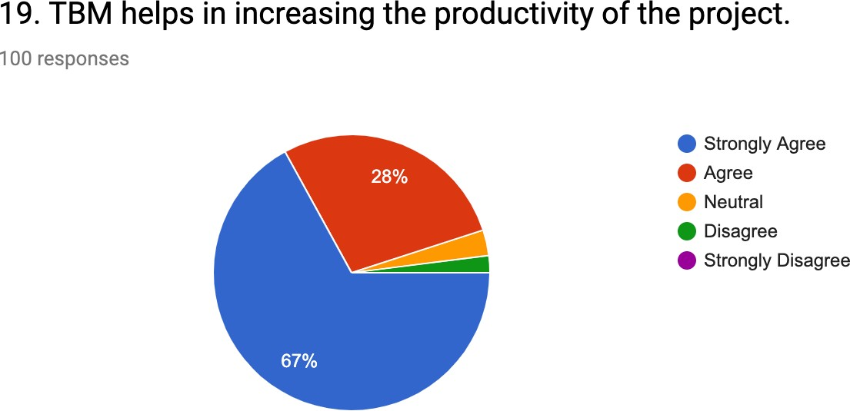

**Figure 4.21 Contribution of TBM in increasing productivity of project**

**Table 4.22 Contribution of TBM in day-to-day work**

|  |  |  |
| --- | --- | --- |
|  | **Frequency** | **Percentage** |
| Strongly Agree | 13 | 13 |
| Agree | 78 | 78 |
| Neutral | 6 | 6 |
| Disagree | 3 | 3 |
| Strongly Disagree | - | - |
| **Total** | 100 | 100 |

From the pie chart, we can be sure that 78% have agreed that the Toolbox Meeting contributes to the smooth running of day-to-day work. 13% have strongly agreed that the meetings contribute to the smooth running if day-to-day work. 6% have stayed neutral in their answers and the other 3% have disagreed when asked if the Toolbox Meeting contributed to the smooth running of day-to-day work. Overall, it can be said that TBM does contribute to the smooth running of day-to-day work.

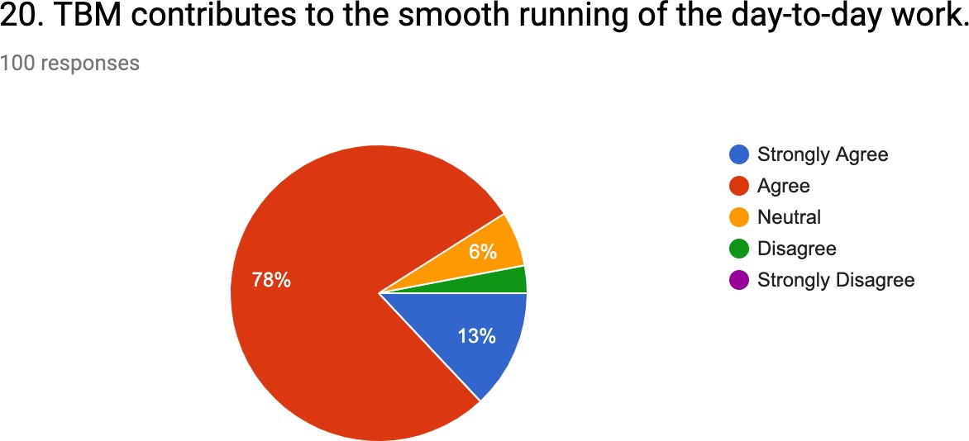

**Figure 4.22 Contribution of TBM in day-to-day work**